I . ABSTRACT

The hydrological cycle consists of several processes that act as variables for climate and climate change. Due to this it has been investigated and predicted that climate change may not only have intense effects on the hydrological cycle, but that the hydrological cycle itself may also reciprocate and influence climate change. It is now recognized that climate change, or global warming, can directly effect precipitation, evapotranspiration, and soil moisture. It has been predicted, using various models all dependent on Global Circulation Models, that the hydrological cycle will be intensified. There will be increases in evaporation and precipitation, which do not cancel each other out due to their unequal distribution. When considering the hydrological cycle, aquifer systems are a source of land surface heterogeneity making their features indispensable for regional scale interpretation, in order to model correct values of runoff and surface temperatures. More focused models present that subsurface saturation both is effected by and has an effect on climate change.

II. INTRODUCTION

According to global assessment by the United Nations, already one third of a 5.7 billion global population survives under conditions of water stress, and about 450 million people are living under conditions of severe stress. Sustainable water supply to which humans have access to is the accumulated river discharge (Q) from mean annual surface and subsurface runoff. When considering water demand pushed by irrigated agriculture, domestic and industrial sectors as a fraction of the sustainable water supply, DIA/Q, UN estimates for the percent population (2000) living under water stress conditions are supported. Table 1 shows the individual estimates. (Vorosmarty et al, 2000)

Table 1. World population (2000) living under progressive levels of relative water
demand. Water stress definition and standards have been set by the UN.
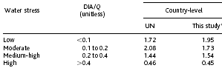

Countries experiencing water stress are concentrated in southern and northern Africa, around the Mediterranean and Middle East, southern Asia and Indian subcontinent, Central America, and large parts of Europe. (Ranjan et al, 2006) This is a predominant portion of the land mass and human population on Earth. Figure 1 illustrates how water stress is apparent across arid and semiarid regions, and densely populated regions of humid tropics and temperature zone. (Vorosmarty et al, 2000) Pressures are believed to increase drastically in Africa and parts of southern Asia and Eastern Europe. (Ranjan et al, 2006) This emphasizes the need for an integrated approach in collaborating climate change, water resources, and socioeconomic communication in order to strategize for a better future.

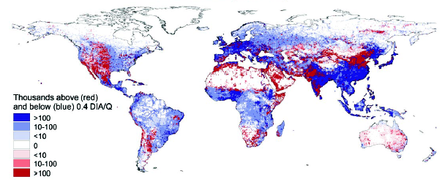

Figure 1. Global distribution of areas under water stress condition, which the color red denoting areas of extreme water stress.

Climate change did not grow to be of major concern until the last few decades. Post the Industrial Revolution there was observation of soaring concentrations of green house gases, including the birth of synthesized gases known as CFCs. These increases in concentrations along with residence time are listed in Table 2. Climate change is governed by solar irradiance, surface albedo, surface energy fluxes, cloud properties, surface temperature, and greenhouse-gas concentrations. The latter has been the cause of recent climate changes and the fear for future climate change. (Loaciga et al, 1995)

Table 2. Concentrations and residence times of significant greenhouse gases. (Vorosmarty et al, 1995)
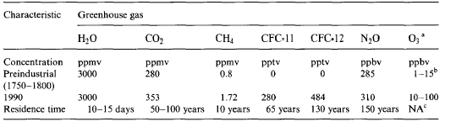

In order to understand climate change, knowledge of how Earth’s atmosphere regulates surface temperature must be attained. This “greenhouse effect” is driven by the primary source of energy that heats Earth, solar radiation (measured in Watts per square meter). A solar constant has been measured by satellites to give a range of 1365 to 1372 Wm⁻². Only a fourth of this goes to work as solar insolation after considering Earth’s spherical geometry, resulting in an average flux of solar radiation of 342 Wm⁻². The net input is 237 Wm⁻² because 105 Wm⁻² is reflected back to space due to planetary albedo, currently approximated to be 30%. Approximately 169 Wm⁻² of this net value is absorbed by surface and about 68 Wm⁻² is absorbed by the atmosphere. (Loaciga et al, 1995)

S_{down} L_{up}

-------------------------------------------------------------------
SH LH
S_{up} L_{down}

Figure 2. Diagram of Earth’s energy fluxes. S is “solar” radiation, L is “longwave” radiation;
SH is sensible heat; LH is latent heat.

From these values it is evident that Earth’s atmosphere is cooler than the surface, or it is the case generally. The vertical atmospheric profile, Figure 3, depicts how temperature decreases towards the tropospause. Due to the atmosphere’s relative coolness, its gas molecules can absorb more energy than emit (Stefan-Boltzmann Law), permitting it to maintain the energy emitted by the surface to warm the surface. Put quantitatively, mean effective radiative temperature is approximately -18ºC, although Earth’s surface reads a global mean temperature of approximately 15ºC. This difference of 33ºC is due to the atmosphere’s greenhouse effect. The surface-atmosphere system is comprised of emitted surface radiation trapped by the atmosphere’s greenhouse gases, giving a net estimated result of 153 Wm⁻² under today’s equilibrium conditions. This is the greenhouse effect, which is what is subject to being dangerously enhanced because of increased concentrations of greenhouse gases. (Loaiciga et al, 1995)

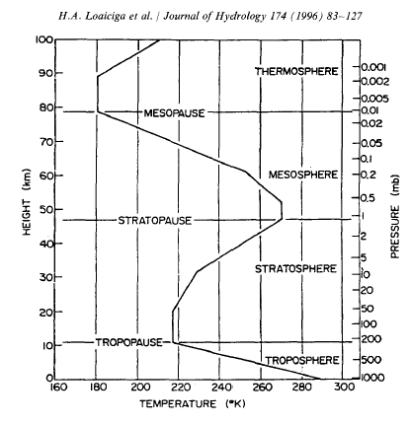
Figure 3. Vertical atmospheric profile. (Loaicigs et al, 1995)

The change in climate due to increased concentrations of greenhouse gases is not only complex, but inadequately comprehended. Svante Arrhenius (1896) was the first scientist to study the effect of increased CO₂ concentrations on surface temperatures, after acknowledging mathematician, Jean-Baptiste Fourier’s, understanding of the greenhouse effect. Current predictions are compatible with Arrhenius’ results, in which surface temperatures increased from doubling CO₂ concentrations. (Loaiciga et al, 1995)
In order to analyze the effect of the atmosphere’s greenhouse gases, their roles must be considered. The predominant greenhouse gases are water vapor, which includes cloud particles (water droplets, aerosols, ice crystals) and carbon dioxide, in respective order. Together they contribute 95% of the greenhouse effect. Water vapor allows for trapping of energy of about 100 Wm⁻² and CO₂ allows for about 50 Wm⁻², out of 153 Wm⁻². The remaining five percent is comprised of mainly ozone, methane, nitrous oxide, and chlorofluorocarbons (CFCs). (Loaiciga et al, 1995)
Human influences play a major if not the biggest role in increased greenhouse gas concentrations. Carbon dioxide is an important byproduct of human activities, but chlorofluorocarbons are actually an anthropogenic innovation of the 20th century. It ha been estimated that CFC potentials will be 7100 times that of CO₂ over a twenty year period. About 90% of its concentration, when reacted with ozone, is located in the stratosphere, making it a very effective absorber of incoming solar ultraviolet radiation and hence a strong influence on climate change. The resulting heating is enough to cause the temperature inversion at the tropopause, the troposphere-stratosphere boundary. Opposite of the troposphere, temperature increases with height in the stratosphere (Refer to Figure 3). However, CFCs actually deplete stratosphere-ozone which further contributes to surface warming by increasing solar radiation flux toward surface. This in turn, allows for stratosphere cooling. Overall, the combination of ozone with CFCs enhances the greenhouse effect in the troposphere while cooling the stratosphere. (Loaiciga et al, 1995)

III. HYDROLOGY IN CLIMATIC CHAOS

To understand the relation between hydrological cycle and climate, how Earth’s climate works must be elaborated. Climate is driven by the unequal distribution of heat and of moisture. Because Earth is always at a tilt, there is an uneven latitudinal input of solar radiation. This is what causes the worlds seasons and also is the force causing heat transport from the equator towards the poles, known as the atmospheric heat balance. The uneven and unequal distribution of land and water on Earth, with land taking up only 30% while oceans comprise 70% of Earth’s surface, causes there to be moisture circulation in order to maintain balance. There distribution determines large-scale atmospheric and oceanic circulation patterns. Their dissimilar heat capacities, ocean having a much greater capacity relative to land, drives continental-scale convective atmosphere transport. In conclusion, convergence and divergence of atmospheric moisture is governed by the Earth’s tilt, and random distribution of and unequal magnitude of land and ocean masses. (Loaiciga et al, 1995)

General Circulation Model

General Circulation Models, or GCMs, are formulated to simulate climate sensitivity to increased concentrations of greenhouse gases, primarily carbon dioxide. The Law of Conservation of Mass equations, applied to Earth’s atmospheric balance processes, are numerically distinguished and solved within an alterating system of coordinates in terms of atmospheric variables such as wind speed and direction, temperature, humidity, precipitation, surface pressure, and so on. Variables of solar radiation at top of atmosphere, topography and land-sea distribution, in addition to albedo of unvegetated land, surface roughness and vegetation characteristics are the boundary conditions of General Circulation Models (GCMs). Ocean and atmosphere conditions can be calculated separately, with corresponding names of Ocean or Atmosphere General Circulation Models (OGCM; AGCM). Constructing a GCM comprised of a ocean-atmosphere system is what seems to be the setback in properly simulating the effects of climate on hydrology. (Karl et al, 2003 and Loaiciga et al, 1995)
In order to study the impacts global warming has on the hydrological cycle and therefore groundwater, the coupled nature of a climate system must be investigated. However, to this day there are still extensive limits on AGCM-OGCM coupled models. This is the primary problem, in the sense that couples, such as ocean-atmosphere, land-atmosphere, biosphere-atmosphere, are particularly difficult to model. None have had accepting finite resolution to properly simulate regional hydrological variables, such as surface contrasts in vegetated soil and topography, for the entire planet. It has not been possible for even coarser resolutions. (York et al, 2001 and Loaiciga et al, 1995) An example a coupled model is the Hadley Centre’s coupled ocean-atmosphere model (HadCM3). The limitations of coupled models could be the distinction between the measuring scale of the atmosphere (days/fractions of days) and ocean (up to 1000 years), or the miscomprehension of how systems are actually coupled. Unfortunately, simulating global warming induced hydrological modifications, particularly its aquifer systems, are dependent on these coupled processes in the atmosphere, oceans, ice caps, land, and biosphere. (Loaiciga et al, 1995) It is essential do achieve this in order to determine how water resources may be influenced by global climate change, how groundwater effects latent and sensible heat fluxes to the atmosphere, and the linkages between ecosystem dynamics and hydrologic cycle. (York et al, 2001)
Scientist E.N. Lorenz (1963, 1964) characterized weather as being of a chaotic nature. So chaotic that if a butterfly were to flap its wings in some part of the world, it would cause such a disturbance in the atmosphere to affect the weather in another part of the world. (Loaiciga et al, 1995) This so-called “butterfly effect” may be an extremist point of view of weather and climate sensitivity, but for that same reason it emphasizes the value of creating more realistic models. If any small change in structure or parameter of a model could potentially cause chaos, then we would hope to have the most realistic structure and parameters established. The essentiality of realistic models is also enlightened and continues to be reinforced from the predictions accumulated so far from using general circulation models.

IV. MODELING

MACROSCALE HYDROLOGICAL MODELING

Macroscale hydrologic modeling has largely and currently still depends on Global Circulation Models. For a continental scale, GCMs can be interactively linked with Macroscale Hydrologic Models (MHMs). The first reported parametrization of hydrologic cycle within a GCM was created by Syukoro Manabe in 1969, and is known as the Simple Bucket model and land surface hydrology. Today, models have evolved into a new era of complexity, trying to internalize as many processes within one model. For instance, Soil-Vegetation-Atmosphere-Transfer Schemes (SVATS) take this complex approach of joining hydrological processes with atmospheric processes. Together with GCM imputs, SVATS is used to measure runoff. (Liang et al, 2002 and Loaiciga et al, 1995) The Biosphere-Atmosphere Transfer Scheme (BATS) created by Dickinson et al in 1986 also takes this more complex integrating approach, diagrammed below in Figure 5. Models like these, having taken a multiple-scale approach by having nested a subgrid model within a GCM, allows for more realistic insight on how hydrological processes function with climate change.

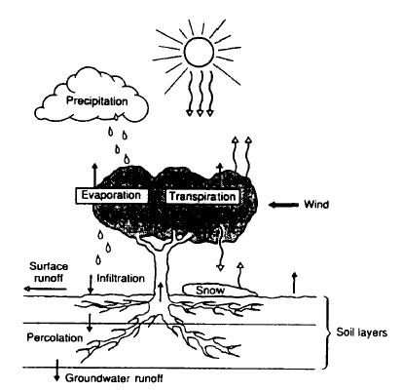

Figure 5. Representation of Dickinson et al.’s (1986) BATS model. (Loaiciga et al., 1995)

General Circulation Models still hold several uncertainties, including future greenhouse gas emissions and their conversion into atmospheric concentrations to push radiative forcing. The misrepresentation of climatology as well as parameter and structural sources of error in hydrochemical and ecological models used in impact assessment, are some other strong uncertainties. (Wilby et al, 2006)

Predictions

General Circulation Models have been able to predict the global hydrologic impact due to climate change, or global warming, by studying the feedbacks of water vapor, clouds, surface albedo, soil moisture, vegetation as well as ocean-atmosphere interactions. Studies have generally given negative feedbacks when focusing on the potential impacts on water resources by global warming. These include the notions of a shorter precipitation season with increases in larger volumes of runoff over shorter period, as with floods. Runoff is believed to be greater during the winter season and less attached to stream snowmelt. This allows for greater obscurity in water storage and flood routing and greatly reduces the time available for groundwater recharge. These all complicate the process for protecting life and property and meeting water supply targets. (Holman et al, 2006, Loaiciga et al, 1995, Bloomfield et al, 2006, and Wilby et al, 2006)
Three versions of GCMs, the Hadley Centre’s coupled ocean-atmosphere model (HadCM3), the Canadian Centre of Climate Modeling and Anaylsis model (CGCM2), and the Commonwealth Scientific and Industrial Research Organisation model (CSIRO Mk2), all predicted similar results. (Wilby et al, 2006) These predictions can also be supported by the United Kingdom’s most widely used scenario, the UK Climate Impacts Programme (UKCIP02). (Bloomfield et al, 2006) The former models agreed in increases in winter precipitation, ranging from +15% to +62% in 2080s, and a divergence in changes in summer precipitation, ranging from -36% to +54% by 2080s. Precipitation extremes were found to be during later summer and throughout the winter. Potential evaporation increases in winter by +3% to +9% and in summer by +5% to +16% by the 2080s. The models’ precipitation and evaporation trends confirm that in the future there will be drier summers and wetter winters as a reaction to climate change. (Wilby et al, 2006)
The conversion to an overall climate of more hydrological extremes (drought and flooding), is not globally uniform. GCMS have predicted an increase of precipitation by 10% with a mean global temperature increase of 2ºC. Not only is this amount of surface temperature increase indefinable until the mid 21st century, but its affects are not distributed equally around the world. There will be areas where precipitation remains unaffected although surface temperatures rise, therefore increasing evapotranspiration which deducts watershed yields in these regions. In the tropical latitudes, mean temperatures will remain relatively high and uniform throughout the year. This can lead to the assumption that water resources in these regions will not be affected due to the balance caused by increased hurricane activity, however this has yet to be proved. The predictions by GCMs for the global hydrological impacts from and for global climate change, have been gathered by studying hydrological feedbacks. (4)

Feedbacks

An increase in carbon dioxide concentrations has shown greater infrared emission toward the surface, which in turn raises surface temperature. A rise in surface temperature causes greater evaporation rates, leading to a rise in atmospheric humidity and so the rise in latent heat absorbed in atmosphere. The troposphere experiences a raise in temperature due to this increase in latent heat as well as by the initial absorption and trapping of infrared radiation permitted by water vapor and other greenhouse gases. A warmer atmosphere holds a greater water vapor capacity, which allows for a greater heating potential. It is this flexibility in atmosphere humidity which plays the center role in potential climate warming.

Cloud Feedback
Present climate presents a mean cloudiness of about 50%, which causes both negative and positive forcing. Negative forcing occurs with the reflection of incoming solar radiation back to outer space, thereby reducing the energy flux arriving at surface compared to clear sky parts. The trapping of infrared radiation which contributes to surface warming is positive forcing. Global mean net cloud forcing has been measured to be -16 Wm⁻², meaning clouds in today’s climate have a negative force effect, providing a 10ºC to 15ºC cooling effect at surface. Doubling current CO₂ concentration of 300ppm, results in a net positive forcing of close to 4 Wm⁻², which would cause a 2ºC to 4ºC increase in surface temperature. Although there would be increased humidity from increased CO₂, the GCM predicts a decrease in global mean cloud cover. It is considered to be an effect of increased drying in the upper troposphere by cumulus subsidence plus midlatitudinal moisture flux divergence which would inhibit cloud formation. This loss of cloud cover amplifies positive forcing because there is less influence of the cloud’s albedo, meaning less radiation would reflect to space.
Despite these reasonable results, there is great uncertainty in cloud feedback. GCMs are too simplistic in its parametrization of clouds and do not properly address possible diurnal and seasonal cloud shifts, changes in latitudinal cloud cover, cloud cover shifts due to surface albedo variations, or changes in cloud optical thickness. These boundaries are beyond what allows the model to be reasonable, especially since there is a strong interaction between water vapor, lapse rate, surface albedo and cloud feedbacks.
Essential in distinguishing hydrologic impacts on or by global climate change, is the study of feedbacks at the surface-atmosphere interface. Parametrization is particular difficult to calibrate and validate for this situation. For instance, the influences of soil moisture and vegetation are so poorly understood that they purely rely on GCM simulations.
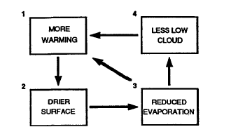
Figure 5. Abstract representation of the soil-moisture feedback (Loaiciga et al, 1995)

Soil Moisture Feedback
Soil moisture and its feedbacks are dependent on several hydrological processes such as precipitation and cloud cover. Since reduced precipitation is regional, its soil moisture feedback is at a regional scale. Diminished precipitation will lead to drier soils, which would in turn drop evapotranspiration. Reduced evaportranspiration will lower cloud cover and therefore evaporative cooling from this latent heat removal. Since the atmosphere is also less reflective due to less cloud cover (cloud albedo is greater than surface albedo), there is a net positive force. Therefore, with an increase in greenhouse gases, soil moisture feedback would lead toward a warmer climate. Figure 5 demonstrates the dynamics of soil-moisture feedback. (Loaiciga et al, 1995)

Surface Albedo Feedback
A warmer climate would cause further melting of ice and snow, which has already been witnessed in our time. Because these water phases hold a stronger albedo than liquid water, their melting would cause for an overall reduction of planetary surface albedo. Reducing solar radiation reflection, increases its absorption. So this ice-albedo feedback will cause positive forcing. Simulations show that positive forcing is more severe at sea-ice margins and polar regions, which accentuates the role of vegetation. (Loaiciga et al, 1995 and Karl et al, 2003)

Vegetation Feedback
Biosphere interaction with the atmosphere is another variable that is poorly understood. Plant growth and respiration depend critically on so many land and atmosphere variables, such as atmospheric CO₂ concentrations and temperature and soil moisture, that the biosphere-climate system maintains several uncertainties. Vegetation feedbacks from global warming may be generated by changes in types of vegetation able to survive. Vegetative cover, or the lack of, directly influences surface temperature either because of varying albedos or varying CO₂ exchange between plant respiration processes. Vegetative cover can not only be altered by excessive greenhouse warming, but also through the anthropogenic stress of deforestation, which can reduce precipitation rates by up to 20%. This is an example of anthropogenic influences for global climate change that has yet not been implemented within models. (Bloomfield et al, 2006 and Loaiciga et al, 1995)

Ocean-atmosphere Feedback
Ocean-atmosphere coupling is probably the most critical interacting system after Earth’s rotational motion (Milankovitch cycle) which governs the atmosphere’s circulation. It is also the least understood and least numerically practical for modeling. Figure 6 illustrates some ocean-atmosphere system interactions which can activate climate feedback due to having a warmer planet. The prediction of increased precipitation would provide more freshwater which when mixed with ocean water would cause a reduction in salinity. Reduced salinity is analogous to reduced water density, therefore there would be less sinking motion which would cause a decrease in oceanic circulation. Because this newly fresher and warmer equatorial water is to be transported towards the poles, there is a drop in high latitude surface temperatures (Loop 3). This negative forcing can be partly counterbalanced because of its effect on increasing poleward atmospheric convective heat transport (τ) and ocean-atmosphere heat flux (Q). Loop 2 shows the cycle of how a drop in temperature and hence drop in evaporation will reduce salinity which could further reduce meridonial ocean circulation and affect poleward heat transport. The ocean-atmosphere system shows the complexities of interactions between greenhouse warming, changes in the hydrological cycle, oceanic circulation, and ocean-atmosphere coupling, even though the model has been oversimplified.

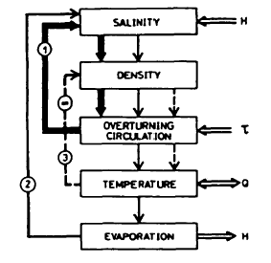
Figure 6. Abstract representation of coupled ocean-atmosphere-hydrologic cycle processes in the high latitudes. (Loaiciga et al, 1995)

REGIONAL MODELING

The previous generation of GCM land surface models (LSMs) considered runoff as precipitation minus evapotranspiration, therefore excluding soil water. Realistically, soil water turns into river discharge and aquifer recharge which may affect fluxes to the atmosphere. Figure 7 illustrates how aquifers interact with the atmosphere under climate change conditions. In order to overcome this omission of soil water, a physically-based watershed approach must be applied. This is accomplished by incorporating lateral transfers of water through rivers and aquifers. (York et al, 2001) And in order to accomplish this, subgrid models which give higher resolutions, must be nested into GCMs.

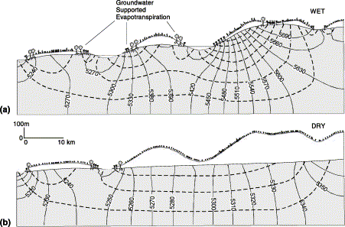

Figure 7. Schematic diagram depicting groundwater supported evapotranspiration, which are areas were a plant root can directly access the water table. (a) is under wet conditions, where the water table is a component of both local and regional flow, and (b) is for dry conditions, where the water table is only a component of local flow. (Vorosmarty et al, 2000)

Aquifers have not been included in physically-based groundwater model because it is not computationally practical to nest into a GCM (multiple-scale approach), but improvisations have allowed for subgrid models within AGCMs to include biogeochemical cycling and ecosystem dynamics. (York et al, 2001) Because GCMs’ resolution for hydrological variables such as precipitation is about 300 km, a spatial average must be taken which makes it unsuitable for short term hydrological processes. Through the multiple-scale approach, hydrologic observations at a regional level, the river-basin scale, can be taken from GCM results. (Loaiciga et al, 1995) These hydrologic observations allow for a focus on the effects of and to aquifers. (York et al, 2001)
Previously, programs such as TOPMODEL and MODFLOW have been put in practice do represent aquifer behavior. TOPMODEL demonstrates the statistical-dynamical method, providing a simplified representation of groundwater and surface flow. Although more computationally effective relative physical-based watershed models, it can not simulate long-term hydrodynamics of aquifers. MODFLOW, being a three-dimensional model, is essential since groundwater levels and streamflow are sensitive to groundwater pumping, recharge rates, and aquifer properties. It has been used in attempt to predict potential effects of climate and land use change on watershed, but it does not allow integration of groundwater-influenced latent and sensible heat fluxes toward atmosphere. Combining the aspects of this model with a LSM (GCM) could supply a coupled land-atmosphere simulation program model. (York et al, 2001 and Liang et al, 2002)
There are three major boundaries for subgrid models, which simulate from GCMs to determine distinct results. Predicting for global warming can not be firmly instituted for at least another few decades since climate is so variable and sensitive. Considering nature’s sensitive appeal, makes it tediously difficult to calibrate and validate the models’ structure. More complex models are needed, but the lack of data leads to paleoclimatic reconstructions which open the door to further inaccuracies. Lastly, climatic feedbacks could distort hydrologic systems, in turn altering parametrization. This would mean that both the hydrologic model and the GCM would have to be tested for accuracy.
CLASP II is a program that utilizes GCM output for watershed scale simulations, classified as an aquifer-soil-vegetation-atmosphere model. It does this by nesting groundwater models such as MODFLOW within a watershed scale system providing a full 3D groundwater model. This improved model makes it possible to focus on aquifer-stream (therefore atmosphere) interaction in a physically-based manner. The larger-scale atmosphere sets the boundary conditions, though the model maintains distinction from ordinary GCMs because of the following reasons. The model uses a decadal timescale for studying the impacts of global climate change on watersheds, which can represent long-term (decades to centuries) groundwater-atmosphere feedbacks and makes it more appropriate to infer groundwater implications on climate change. The latter can be accomplished by studying the change and interaction between the water table and latent heat fluxes. As counteract, the model must be simplified in order to reach this timescale. Short fifteen-minute time-steps are used in order to more appropriately characterize latent and sensible heat fluxes and atmosphere dynamics like cumulus convection. A daily scale is not as functionable because it would omit the detailed mechanism of soil moisture resdistribution or surface water hydrodynamic. Figure 8 shows how CLASP II conceptualizes the interaction between hydrological cycle and atmosphere, and therefore climate change. (York et al, 2001)

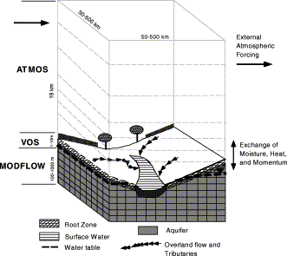

Figure 8. Schematic of the coupled land-atmosphere simulation program model, version 2 (CLASP II). (York et al, 2001)

Limitations

Being a fairly young model, CLASP II (2001) holds several limitations. First off, characterizing the atmosphere as a single column (ATMOS), integrated into MODFLOW, in order to imitate a GCM gridbox, denies horizontal atmospheric heterogeneities within the domain. Also, being slave to the atmosphere’s boundary conditions, puts its credibility as a function of the accuracy of the larger scale dynamics. Overall, there are far too many fixed variables. Variables for stream cells such as elevation, conductance, and streambed slope and roughness are fixed. For aquifer cells, surface and base elevation, hydraulic conductivity and the storage coefficient are fixed. In either situation, soil density and heat capacity are fixed. The groundwater head is set to be constant and no-flow is labeled to occur at the topography-groundwater divide of watershed. For the grid cell taken into consideration, it is assumed to be covered homogeneously by specified vegetation. (York et al, 2001)
Although there are currently calibrated Land Surface Models with more complex so more accurate groundwater-surface models, resulting probably in greater accuracy relative to CLASP II, the model takes a different approach in focusing on water table-at-atmosphere interactions. The CLASP II acts as a compromise between model complexities and computational practicality.

Results

The results obtained using the CLASP II model on annual precipitation and stream discharge seem to be slightly less than climate observations, as illustrated in Figure 9 below. This may be due to using point measurement for precipitation for a 150 km scale. When taking the average precipitation over a 200 km scale, a better agreement between simulated and observed can be achieved. Exact agreement can not be expected since the atmosphere is being modeled as a single column since it does not permit a spatial summation of precipitation measurements. Macropore flow is another function that may limit the study in being able to accurately simulate observed discharge. (York et al, 2001)
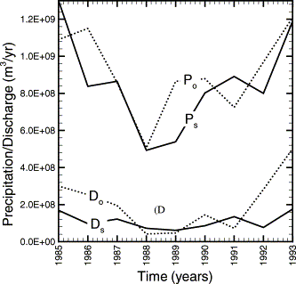
Figure 9. Precipitation and Discharge as measured by CLASP II and compared to observed climate. (York et al, 2001)

There is close agreement between observed and simulated average soil moisture. Differences could be accounted for by the fact that soil moisture and evapotranspiration are averaged over a larger area than the observed measurements are. Because it is a simple soil model, soil moisture may be free to drop too low during dry periods which could cause the smaller trend of simulated soil moisture relative to the observed. The model was able to present an equal daily variability in evapotranspiration measurements between simulated and observed. From the results, it can be gathered that the model simulated soil moisture and evapotranspiration fluxes realistically, but improvement by adding detail could represent observations more closely.
Groundwater simulations appeared to have represented annual precipitation adequately, with the common decline and rise in head between summer and winter. The annual oscillation of 0.5 to 2.0 meters is consistent with the observations of annual variability of limestone-shale aquifers, which was specific to the case study used. Table 3 lists the simulated groundwater levels in comparison to measured.

Table 3. Groundwater levels (York et al., 2001)
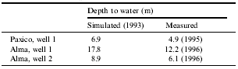

The simulated results were compared for when they included and excluded an aquifer in order to reiterate the importance of groundwater simulations. Figure 10 shows how the evapotranspiration trend is significantly lower for the “non-aquifer” (NA) plotting. The percent change is more evident during drier years, being a reasonable response since greater amounts of water are discharged during dry years (i.e. 1987-9). Streamflow appears to be less for the non-aquifer simulation because of differences in precipitation and since saturated overland flow is not taken into consideration, but does not effect comparison of evapotranspiration. It can therefore be concluded that groundwater evapotranspiration provides a substantial contribution to the atmosphere. (York et al, 2001 and Ranjan et al, 2006)

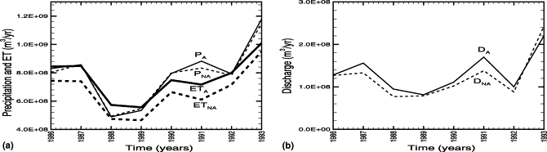

Figure 10. Comparison of simulated annual (a) precipitation (P), and evaportranspiration (E); (b) stream discharge (D), for ‘Aquifer’ and ‘Non Aquifer’ simulations. (York et al, 2001)

Hydrological processes of groundwater, such as changes in groundwater levels, hydraulic gradients, groundwater fluxes and water quality, hold no or little threshold for climate sensitivity. This is what initiates the complexity of groundwater managements and well as modeling. Variables are extensive while model structure validation is poor. The uncertainty of climate change only adds to the groundwater complex. Although climate change predictions using mono or multi-scale approaches to General Circulation Models have been useful in presenting certain climate scenarios, the lack of data available, the never-ending complexity of nature, and the range of climate-sensitive processes all call for models containing a more detailed backbone and more truthful parametrization. (Holman et al, 2006; York et al, 2001; Loaiciga et al, 1995; Bloomfield et al, 2006)

V1. INDIRECT IMPACTS OF CLIMATE CHANGE ON GROUNDWATER

Along with the direct effects of climate change on groundwater, follow its indirect affects, including indirect climatic effects and socio-economic factors. Another side effect of global warming is the rise in sea level due to greater precipitation and the melting of ice caps. This rise in sea level can be detrimental for the integrity of coastal aquifers. Figure 11 represents how fresh groundwater could be lost due to salinity intrusions. At Interface 1, the aquifer is saturated with freshwater, therefore loss is zero. The landward movement of salinity interface is what leads to a reduction in freshwater in the aquifer. At Interface 3, the loss of freshwater is at 100% because this is where salinity interface overlaps with the aquifer’s piezometric head, leading to saturation in saltwater. The Mediterranean and Central American region have experienced the greatest rise in sea level, respectively, making their coastal aquifers more susceptible to sea water intrusions.

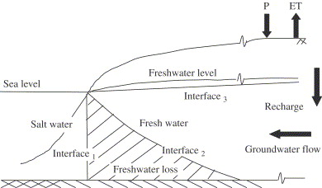

Figure 11. Schematic diagram of loss of fresh groundwater resources to salinity intrusion in coastal aquifers (Ranjan et al, 2006)

Along with the indirect impact on aquifers due to climate change, are the broader indirect affects of socio-economic factors such as population growth and land use efficiencies. Figure 12 shows the effects of different climate scenarios on water supply distribution, properly presenting the great impact of population growth. Population growth especially affects peoples of already water stressed regions because it is an added stress factor in addition to their insufficient water use patterns with life style and the degradation of watersheds caused by land-use changes. For instance, southern Asian countries hold the highest overall population density in the world. Increasing demands in domestic, agriculture, and industrial sectors would only place additional stresses on water resources and on the power of its society. Even if this region had the best groundwater availability, its availability per capita would not suffice and probably continue to deteriorate. Although it is predicted that Africa will suffer greater impacts due to lack of water availability, due to its lower population density the region has a stronger per capita availability. However, its discrepancies lie largely in lifestyle. (Ranjan et al, 2006)

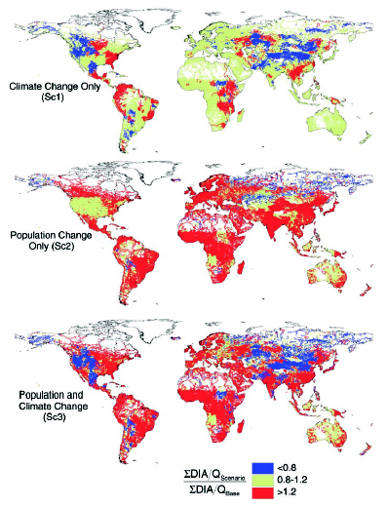
Figure 12. Distribution of water stressed regions according to different climate scenarios. (Ranjan et al, 2006)

Poverty, like that of Africa, can be so impacting that it must be linked to the environment. Africa’s economy is specifically recognized to exploit its natural resources, so a better per capita availability of groundwater is useless if poor communities, a majority of the population, do not have the capacity to gather or technology to access deep groundwater resources. This is why there has been a trend in increasing coastal populations. However, intensity of the use in coastal resources again makes them unattainable. Arnell (1998) suggests that even without climate change, it is probable that there will be increases in future domestic water demand due to population growth, per capita consumption, and use of water-wasting domestic appliances or habits such as a dishwashers and garden watering. Downing et al (2003) estimated that demand increases from 1621/household/day (1997-8) to 2031/ho/day (2024-5). Adding the impacts of climate change allows for a 1.8% increase which appears to be modest, but in conjunction with a decrease of water supply this small percentage can be destructive. This can even be subcategorized to show that industrial and commercial water demand is more greatly influence by climate change, by 2.8%. (Ranjan et al, 2006 and Bloomfield et al, 2006)

Estimates of future water supply already are in vast range due to varying population growth and land use efficiencies. These indirect factors can be even harsher than direct impact when considering agriculture. Land use and land management changes can be greater impacts of climate change than the induced physical change in soil structure. For instance, there could be a change in demand for using pesticides and most probably an increased demand for water for agricultural aspects. The indirect effects of climate change on agriculture however are very uncertain since its impacts function under many different mechanisms which are initially and strongly misunderstood. These mechanisms include changes in plant physiology, altered soil water balances, impact on yields, changes in cropping patterns to take advantage of longer growing seasons, introduction of new crops, total area under irrigation, changes in demand for agricultural products, changes in food imports due to effects of climate change elsewhere in world. Water resources decision making is completed using a critical period approach, in which the future is assumed to be a statistical replica of hydrological regime recorded in the past. These predictions hold very limited and controversial reliability. (Loaiciga et al, 1995) Once again, the uncertainties of climate change impacts, just as for direct effects, are vast for indirect effects. (Bloomfield et al, 2006)

V1I. CONCLUSION

The significance of water resources to climate change physically relies on global warming from an enhanced greenhouse effect and the hydrological cycle, as well as on the water management due to indirect impacts. An integrated approach to bringing together climate change, water resources, and socioeconomic communication would be essential for future progress. The dependence of climatic scenarios lying completely in General Circulation Models allows for much room in prediction uncertainties as well as for the call on new more realistically, more detailed, approach to modeling the hydrologic relation to climate change. It is essential do achieve this in order to determine how water resources may be influenced by global climate change, how groundwater effects latent and sensible heat fluxes to the atmosphere, and the linkages between ecosystem dynamics and hydrologic cycle. Fresh groundwater is a key component to the survival of all life and system on Earth. The negative impacts predicted to be imposed by climate change, or even the those imposed by groundwater to climate change, must be elaborately study in order to secure a better future or be prepared for certain circumstance. In either case, groundwater and climatic change correlations need to be more strongly comprehended.

REFERENCES

Bloomfield, J.P., Williams, R.J., Gooddy, D.C., Cape, J.N., and P. Guha. (2006) Impacts of climate change on the fate and behavior of pesticides in surface and groundwater- a UK perspective. Science of Total Environment: 369, 163-177.

Holman, I.P. (2006) Climate change impacts on groundwater recharge- uncertainity, shortcomings, and the way forward? Hydrogeology Journal: 14, 637-647.

Karl, T.R. and Kevin E. Trenberth. (2003) Modern climate change. Science: 302, 1719-1723.

Liang, X. and Zhenghui Xie. (2002) Important factors in land-atmosphere interactions: surface generations and interactions between surface and groundwater. Global and Planetary Change: 38, 101-114.

Loaiciga, H.A., Valdes, J.B., Vogel, R., Garvey, J., and Harry Scwarz. (1995) Global Warming and the hydrological cycle. Journal of Hydrology: 174, 83-127.

Ranjan, P., Kazama, S., and Masaki Sawamoto. (2006) Effects of climate change on coastal fresh groundwater resources. Global Environmental Change: 16, 388-399.

Vorosmarty, C.J., Green, P., Salisbury, J., and Richard B. Lammers. (2000) Global water resources: Vulnerability from climate change and population growth. Science: 289, 284-288.

Wilby, R.L., Whitehead, P.G., Wade, A.J., Butterfield, D., Davis, R.J., and G. Watts. (2006) Integrated modeling of climate change impacts on water resources and quality in lowland catchment: River Kennet, UK. Journal of Hydrology: 330, 204-220.

York, J.P., Person, M., Gutowski, W.J., and Thomas C. Winter. (2001) Putting aquifers into atmospheric simulation models: an example from the Mill Creek Watershed, northeastern Kansas. Advances in Water Resources: 25, 221-238.

